**Name: Umamah Hussain**

**Roll Number: 21L-1858**

**Section: BSCS-5C**

DB TASK 2:

1. **Remove the customers belonging to the UK.**

Before Query:

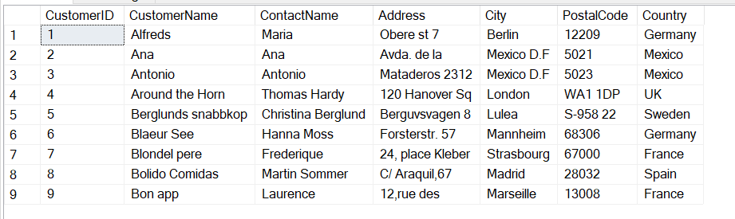

After Query:

delete from customer

where Country='UK';

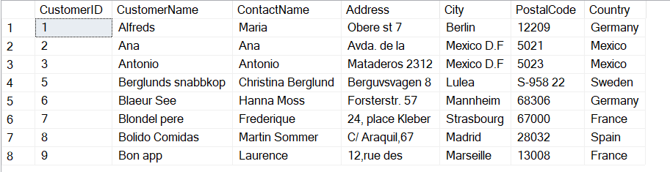

1. **Retrieve the customer's name, address, contact information, and country.**

After Query:

select CustomerName,Address,ContactName,Country

from customer

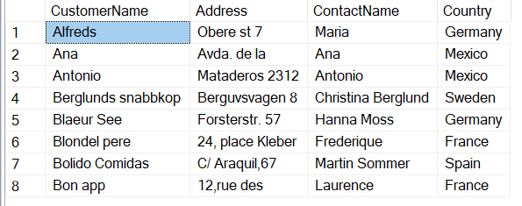

1. **Fetch the details of the employee with EmployeeID 1.**

Before Query:

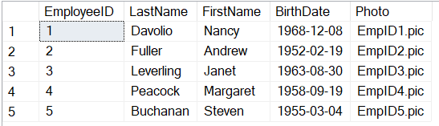

After Query:

select * from employee

where EmployeeID=1

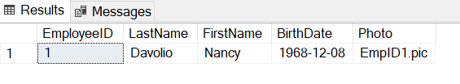

1. **List order details (orderID, customerID, EmployeeID) for orders with orderID greater than 10253.**

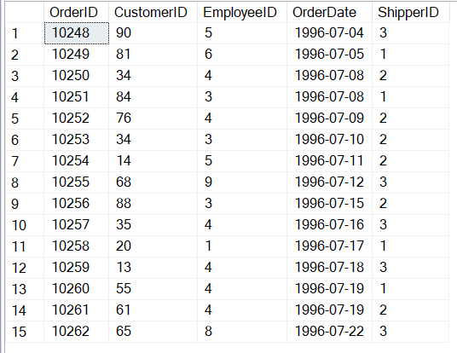

After Query:

select * from orders

where OrderID>10253

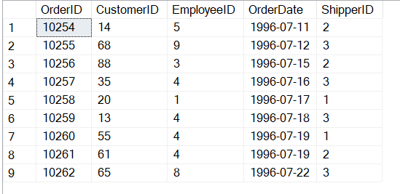

1. **Arrange the customer table in descending order based on country.**

select * from customer

Order by Country desc

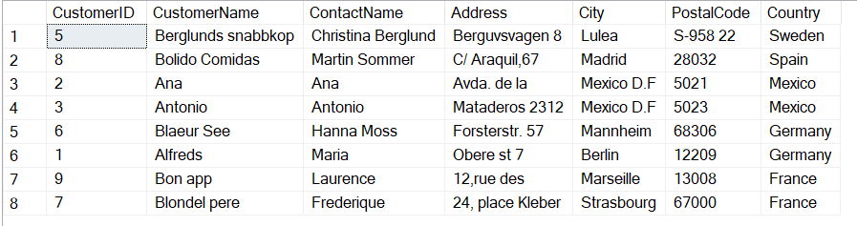

1. **Arrange the customer table in descending order based on both country and customer name.**

select* from Customer

Order by Country desc, CustomerName desc

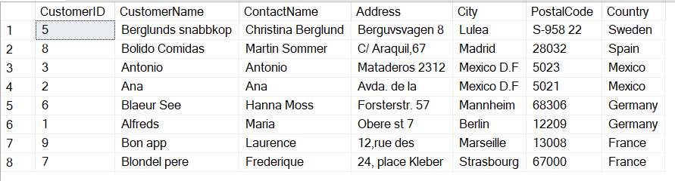

1. **Retrieve only customers not originating from the UK.**

select* from Customer

where Country!='UK'

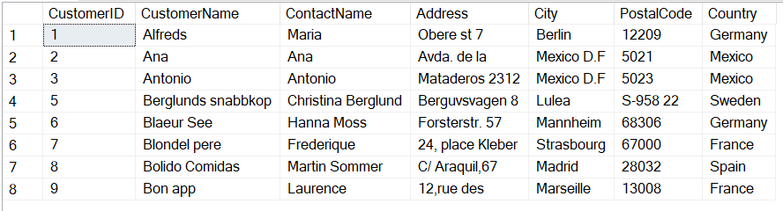

1. **Select customers whose names do not start with the letter 'B'.**

select* from Customer

where CustomerName not like 'B%'

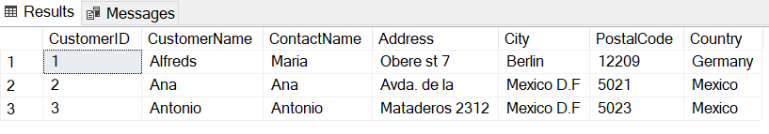

1. **Choose customers with a customerID falling outside the range of 20 to 50.**

select* from Customer

where CustomerID<20 or CustomerID>50

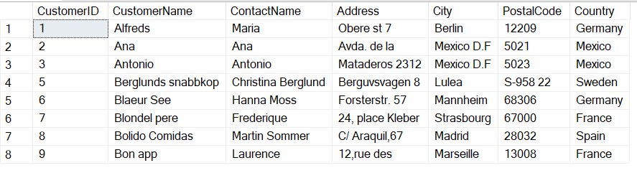

1. **Retrieve all customers from Germany or Spain.**

select* from Customer

where Country='Germany' or Country='Spain'

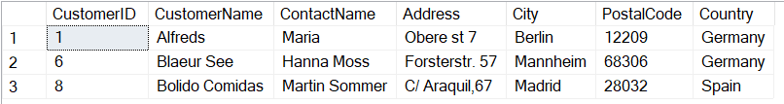

1. **Retrieve all customers from Germany or Spain using the IN operator.**

select* from Customer

where Country in('Germany','Spain')

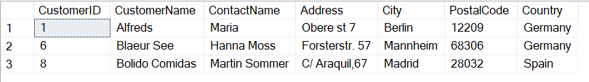

1. **Display the top 10 order details.**

select Top 10* from orders

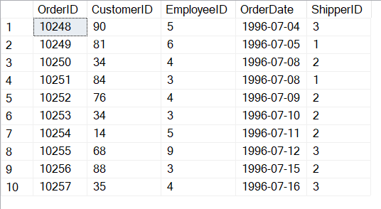

1. **List customerIDs of those customers who have placed orders using a set operation.**

select CustomerID from customer

intersect

select CustomerID from orders

1. **List employeeIDs of those employees who do not appear in the order table using a set operation.**

select EmployeeID from employee

except

select EmployeeID from orders

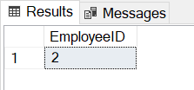

1. **Provide a list of unique country names from the customer table.**

select distinct Country from customer

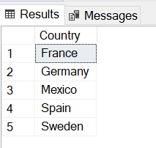

1. **List customer names, contact details, and countries for those who have placed orders.**

select CustomerName, ContactName, Country

from customer, orders

where CustomerID = OrderCustomerID

//assuming that CustomerID is the column name of Customer IDs in the customer table and the OrderCustomerID is the column name in the orders table that has the IDS of the customers that have placed the order.